**Consolidate Interface**

|  |  |  |
| --- | --- | --- |
| *nearly identical classes cannot be consolidated due to the dependency on a package specific interface* |  | *generalize the interface and retrofit existing clients to free these classes from their package limitations* |

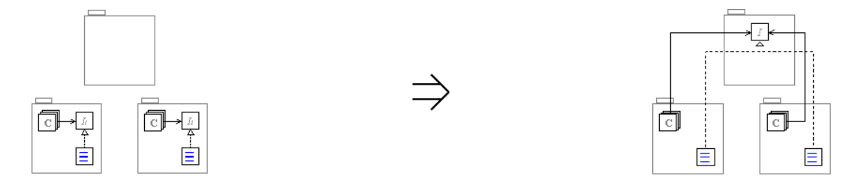

**Context:**

See also: [Consolidate Interface](https://web.archive.org/web/20090914084938/http:/www.refactoring.be/thumbnails/ec-consolidate-interface.html)